VIOLENCE DETECTION SYSTEM

Vijay Kumar Sharma

Dept. of Computer Science & Engineering,

Meerut, India.

[vijay.kumar@miet.ac.in](mailto:vijay.kumar@miet.ac.in)

***Abstract***— **Security has become the prime concern for everyone in present scenario. If you are in home, road and other like colleges, company and hospitals E.T.C, you have to be pretend yourself for annoying activity and have to secure you and your area for suspicious activity. In this work an attempt has been made to develop a Face Security System which is accessible, affordable, fully managed, secure and work with real time analysis. The proposed system is based on ‘Automatically Triggered System’ which works both on the WEB and GSM platform for authentication and monitoring. This triggered facility is used with the help of AWS system notification service (SNS). This system is therefore cost effective as it relies on hybrid infrastructure. As we know AWS Rekognition is most popular and efficient tool for face recognition, it has been used in this work. AWS Rekognition technology automatically recognise the objects, scene, activity, facial analysis, unsafe content, celebrities, text in images and as well as Violence with the high percentage of surety. This helps the users to monitor the real-time activities through web services/SMS. The web service consists of either web browser command or e-mail provision. This system automatically Recognise the person who is involve in the past violence activity through real time analysis or using the photo/video. If violence is going to happen then the notification received by the SNS to the authorized person, which will immediately take action on it and to stop violence before it happens. The report is concluded with the authors’ opinion on the project and possible applications.**

**Keywords: AWS Rekognition, AWS SNS, GSM, Violence, Real-Time Analysis,**

# Introduction

There is a wide range of commercial and security applications based on image processing Butan efficient and accurate embedded access control system based on facial Recognition technologyis still a challenge. This technology is being gradually adopted in several applications across the globe. Accurate identification of the violent persons to the control area is the heart of the solution of this modern technology .For the physical control of the entrance of the college area other technologies like AWS Rekognition, Camera, AWS SNS, methods are used in. Face recognition is the real time technique to identify the defaulter person and resolve the violence problem before happen.

Face recognition technique in real-time embedded system is a module of the proposed design. Some of the work has been progressed by the AWS team in this field. For access this system we need a Hybrid Server which store a video and images for real time streaming and when suspicious person found then the notification received by the SNS to the authorized person, which will immediately take action on it and to stop violence before it happen.

This piece of work proposes a wireless access control system and designed a safe environment of the college. The physical components that are needed to be installed for functioning of virtual college security systems are: the camera unit and the Hybrid servers. These components are installed in a college by use of various AWS services. The virtual face security system functions by intimating the college authorised person about any visitor, suspected students, person and real Time monitoring who confronts the camera unit by SMS or E-mail. All the people are verified using real time processing after entering for security and safety. These will be processed in virtual environment prior to real environment implementation and automatic predict the suspicious activity before happens. The proposed system is energy efficient, intelligent, fully managed, real-time analysis, secure, low cost, and delivers high performance.

# Literature

In 1960 Woody et al. gave the first semi-automated facial recognition technique. This technique required some features such as mouth, nose, eyes and nose on the image [] []. After that, face recognition techniques came in the picture. In 2001 onwards this biometric technique increased rapidly. The main goal of this literature is the justification of the constantly increasing scientific interest in face recognition technique. The literature analysis can be achieved by analyzing the publications of the last 51 years related to the face .Facial recognition system is one of the hottest research area. The work defined by the earlier researchers on facial recognition is discussed in this section.

Naveen N. Murthy [] has used the DWT based feature generation and decomposition model under gradient masking. The recognition is here applied by analyzing the facial variation and later on the maximum mapped image is selected as the recognized image over the dataset. This recognition model used the distance based mapping to perform the real time recognition of facial image.

Zixuan Wang [] has presented a work on facial recognition based on the location adaptive robustness. Author defined the system for mobile devices so that the real time authentication will be obtained from the work. Author provided the location adaptive recognition system so that the overall work accuracy will be improved

Security systems presented by Shankar Kartik []also uses Eigenfaces method for face identiﬁcation which gives unfavorable results with moderate accuracy

Yang Zhang[] presented a LBP feature adaptive recognition model to provide the recognition based on the featured integration so that the relatively effective recognition set will be obtained. Author analyzed the work under different facial challenges and provided the feature adaptive recognition. Author obtained the high recognition rate so that the more dynamic and robust recognition system is obtained.

Kanchan Singh[9] has presented DWT adaptive predictive model to improve the recognition for facial images. Author defined the feature extraction using frequency adaptive decomposition. Once the parameter and the relative coefficients are obtained, the eigen distance adaptive mapping is performed to recognize the face.

Weisheng Li[] has a dynamic feature adaptive recognition model to provide the effective recognition based on the central pixel based distance analysis. Author defined the improved feature adaptive model under histogram equalization. Author provided the recognition of facial image under effective rate based on the threshold specification

Facenet[] using deep convolutional neural network [] with the architecture of Inception model from Google and uses a novel online triplet mining method[] to train instead of an intermediate bottleneck layer. On the widely used Labeled Faces in the Wild (LFW) dataset [], Facenet system achieved a new record accuracy of 99.63% .shown in Fig.1.

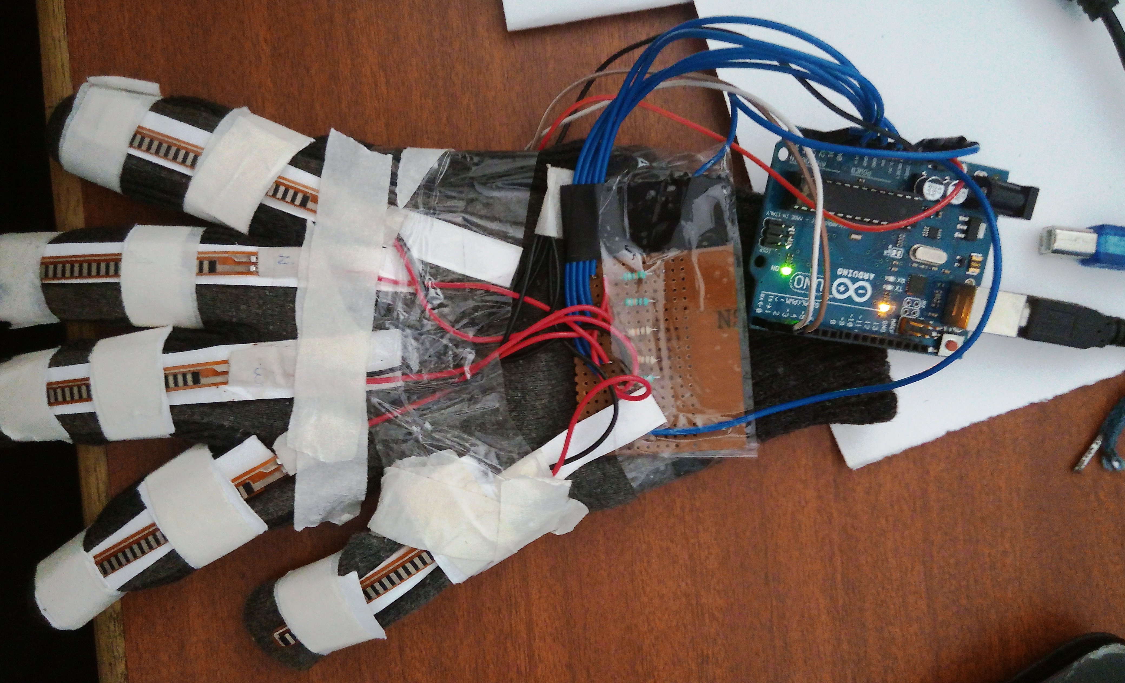

Fig1. Proposed Speaking Glove

**Hardware Description:**

Hardware used in designing speaking glove is explain below,

1. **Flex sensor:** The Flex Sensor patented technology is based on resistive carbon elements shown in Fig.2(a)[9]. As a variable printed resistor, the Flex Sensor achieves great form-factor on a thin flexible substrate.

When the substrate is bent, the sensor produces a resistance output correlated to the bend radius the smaller the radius, the higher the resistance value. As shown in fig2. (b)

We use this property of variable resistor of flex sensor and create voltage divider circuit As flex sensor has a range from about ~10K to ~35K, that means it won't give us a full 0-5 volt range (or 0-1023 analog value). Try to use the serial monitor below to find out what analog value you will take while you bending the sensor. It supposed to be between 700 to 900.

The corresponding values of graph which is output of Fig.2(b)

Calculations of fig.2(c) on various bend of flex sensor are as following:

Formula for voltage divider circuit:

$$V_{0}=V_{cc}\left(\frac{R_{2}}{R_{1}+R_{2}}\right)$$

Consider R1= 10kΩ and R2= resistor of flex sensor on different bending as below

For Vo minimum when sensor deflection is 0o

R1= 10kΩ ,R2=10kΩ and $V_{cc}=5V$

$$V_{0}=5\left(\frac{10}{10+10}\right)=2.5V$$

For Vo middle when sensor deflection is 45o

R1= 10kΩ ,R2=20kΩ and $V_{cc}=5V$

$$V_{0}=5\left(\frac{20}{10+20}\right)=3.3V$$

For Vo middle when sensor deflection is 90o

R1= 10kΩ ,R2=30kΩ and $V_{cc}=5V$

$$V_{0}=5\left(\frac{30}{10+30}\right)=3.75V$$

As flex sensor output resistance output is ranging from 2.5v to 3.75v in straight and bending respectively. Which produce after analog to digital convertor of 10bit in aurdino from 700 to 950.

We use it as digital output, below 700 as logic 0 and above 850 logic 1. This is process by aurdino and makes decision on basic of program.

.

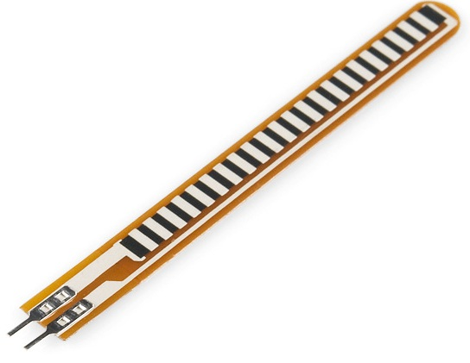

(a)

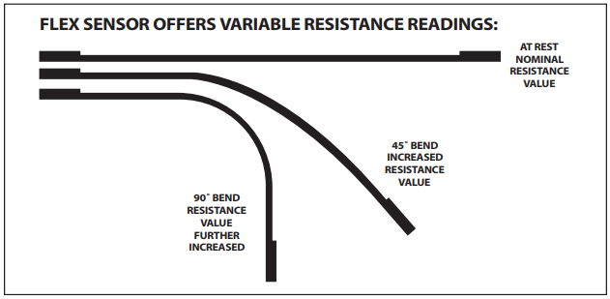

(b)

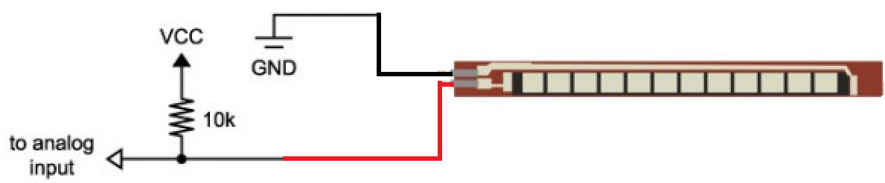

(c)

Fig.2(a) Flex sensor (b) Flex sensor as a variable resistor (c) Flex sensor as voltage variable

1. **Aurdino:** Arduino is an open-source electronics platform based on easy-to-use hardware and software shown in Fig.3. It consist two GND, 3.3v and 5v power supply,  A0 to A5 (6 )Analog Input pins, 0 through 13 on the UNO total 14 digital pin, PWM pin AREF pin and pin 0 & 1 use for Tx and Rx. This board is brain of our project.

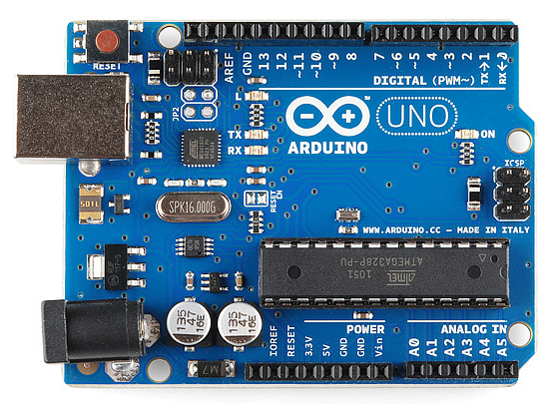

Fig.3. Aurdino UNO board

1. **Bluetooth Module:** we use Bluetooth moduleHC-05 shown in Fig.4 for sending and receiving process by aurdino to mobile application.

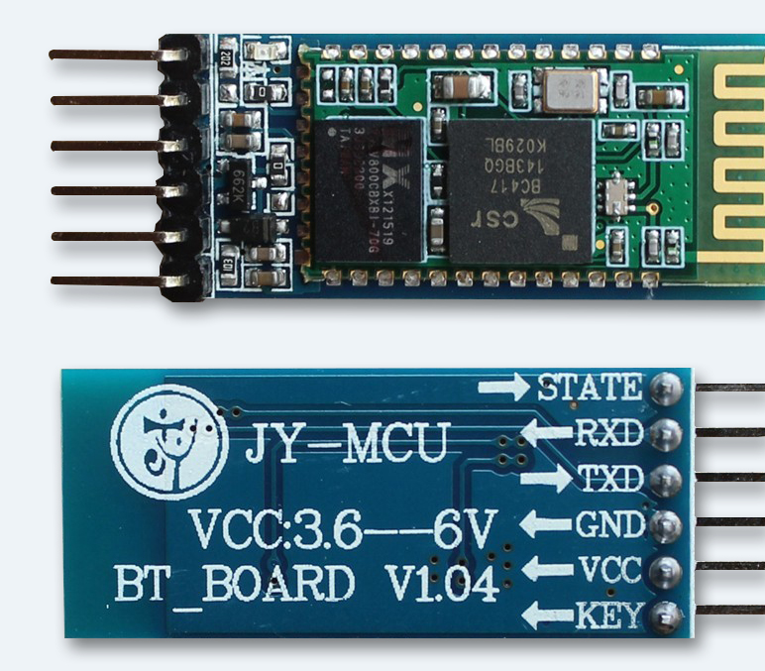

Fig.4 Bluetooth module HC-05

Over all hardware structure shown in Fig5.

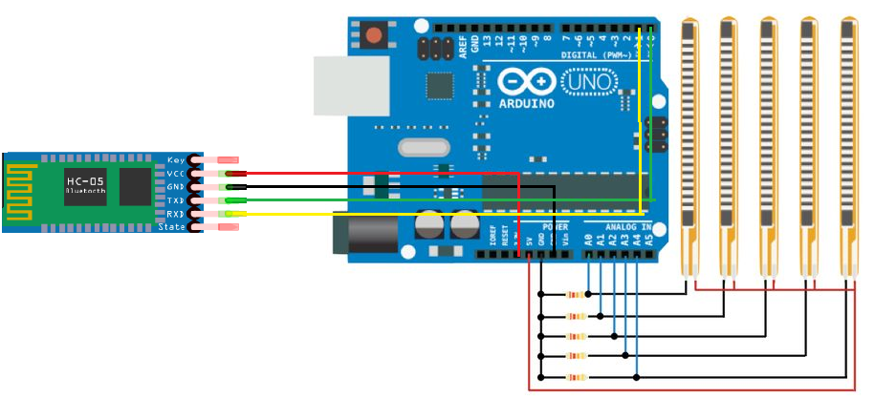

Fig.5 Hardware structure of speaking gloves

**Software section:**

Hardware programming is done of aurdino open software as shown in Fig.6(a) [10]

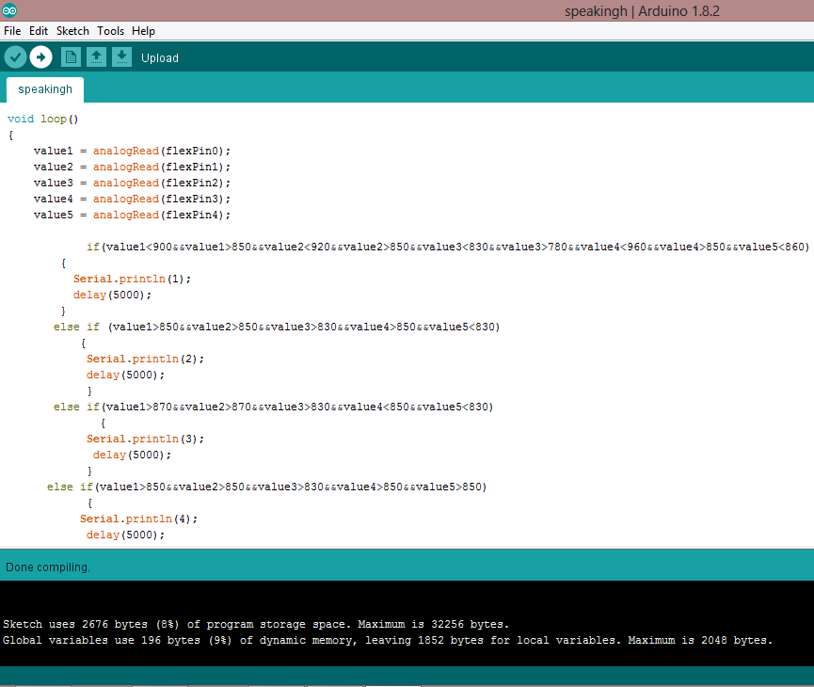

Fig.6.(a) Program of speaking glove

Design of mobile application is done App Inventor for Android is an open-source web application originally provided by Google, and now maintained by the Massachusetts Institute of Technology [10] as shown in Fig.6(b).

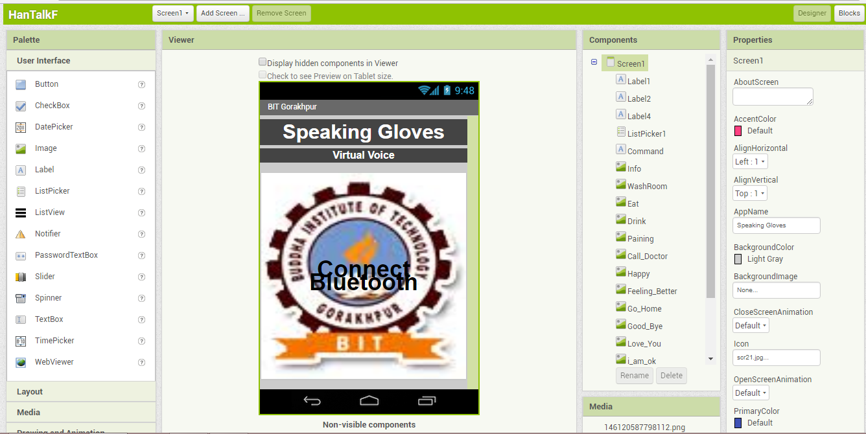

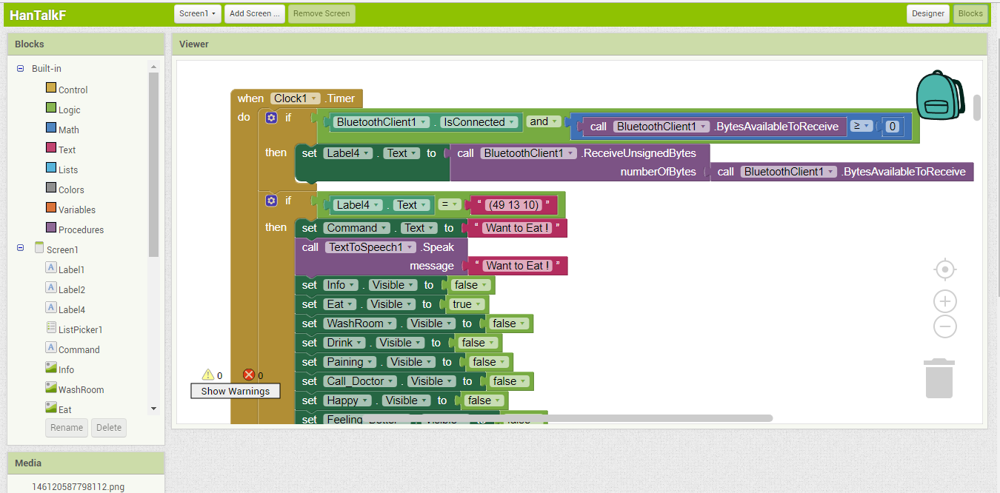

Fig.6 (b) Design of mobile app in App inventor.

**Block Diagram:**

Working of speaking glove is explain on the block diagram as shown in Fig7.

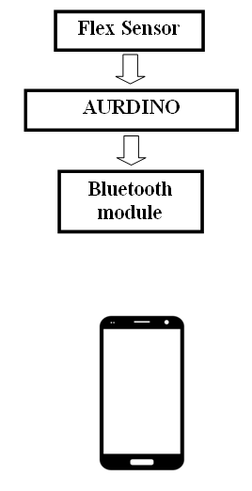

Fig7. Block diagram of working of speaking Gloves.

# As discuss above all hardware and software section. Different gesture is produces respective binary data and respective data is send to mobile app. In mobile app receive data is compare in programming , is any data is match then it display image and produce voice output. Table of different output at different gesture is shown in table.1

Table1.Speaking glove gesture and message output

|  |  |  |  |
| --- | --- | --- | --- |
| S.No. | Bin | Gestures | Message |
| 1 | 00000 |  | No message |
| 2. | 11100 |  | Need water |
| 3. | 01111 |  | I want to go washroom |
| 4. | 11001 |  | Feeling Well |
| 5 | 01110 |  | Call Doctor |

# conclusion

The AWS Rekognition is very accurate and is works with more than 99% accuracy. The system will be able to detect less resolution images, tilted images and even side faces.

It can also detect the actions and verbs like Punching, Kicking and violence etc. That makes it even more powerful

The AWS SNS helps us to send SMS and E-mails to the authorities in real time.

# solution

Amazon Web Service is being used for this project. AWS provides us various services that are very efficient are very affordable. The system will consist of a number of cameras in the building (let say college). We have a folder consisting of images of all the rusticated students and the criminals that have caused harm to the college in the past. For better accuracy we will have at least five photos of each person collected from different sources by using his or her social media accounts. All this data is saved in the folder “Reference faces”. The cameras will record the video and captures the images after a fixed time interval. In the morning since Student’s traffic at the college gate is maximum. Hence images are taken from the video after every 5 seconds. During afternoon the traffic isn’t much. Hence we can reduce the frequency to 1 minute. We have to create an account on AWS and connect it with our system using AWS-CLI by using our account credentials. Once system has been connected with AWS. We run our python code to compare the images in “Face to match” folder with images present in “reference faces” Using AWS Rekognition which is Machine learning API. If any of the person faces matches with face that are not allowed in the building. The AWS SNS is triggered and the authorities are alert regarding same. The SNS sends an Email as well as SMS to the authorities if confidence rate is more than 90% else if confidence is less than 90% First manual checking is required before alerting the authorities. Image Detection is also done and if any image consists of labels like Violence, punching etc. Then too authorities are informed. And the people who did violence, their faces are also added in “Reference faces” folder. The system quite accurate and has more than 99% accuracy. It can even detect and recognize faces in less resolution images. It works fine with side faces and tilted images.

# Future Enhancement

Nothing is perfect in this world, always there is a room for improvement. This project can be enhanced further by using memory which would have real time recorded footage by humans to generate a huge datasets and more natural voice could be heard with ease, To make it 100% waterproof, some protected layers may be fashioned in order to secure

the circuit, battery and speaker.

# References

1. B. Ali, S. Munawwa[1]S. M. Prakash and C. J. Kalpna, “Face Recognition Using PCA,” International Journal of Artificial Intelligence Knowledge Discovery, vol. 1, pp. 25-28, 2011. Article (CrossRef Link).
2. Erdem, H. and Uner, A., "A multi-channel remote controller for home and office appliances,” IEEE Transactions on Consumer Electronics, vol. 55, no. 4, pp. 2184, 2189, November 2009. Article (CrossRef Link).
3. Yuksekkaya, B.; Kayalar, A.A., Tosun, M.B., Ozcan, M.K. and Alkar, A.Z., "A GSM, internet and speech controlled wireless interactive home automation system," IEEE Transactions on Consumer Electronics, vol.52, no.3, pp.837, 843, Aug. 2006.Article (CrossRef Link).
4. Chia-Hung Lien, Ying-Wen Bai and Ming-Bo Lin, "Remote-Controllable Power Outlet System for Home Power Management," IEEE Transactions on Consumer Electronics, vol.53, no.4, pp.1634,1641, Nov. 2007. Article (CrossRef Link).
5. Vernon, S. and Joshi, S.S., "Brain–Muscle–Computer Interface: Mobile-Phone Prototype Development and Testing," IEEE Transactions on Information Technology in Biomedicine, vol.15, no.4, pp.531, 538, July 2011. Article (CrossRef Link).
6. Faundez-Zanuy, M., “Are inkless fingerprint sensors suitable for mobile use,” IEEE Aerospace and Electronic Systems Magazine, Vol. 19, No.4, pp. 17-21, April 2004.Article (CrossRef Link).
7. IFaundez-Zanuy, M., “Technological evaluation of two AFIS systems,” IEEE Aerospace and Electronic Systems Magazine. Vol. 20, No.4, pp. 13-17, Aprll 2005.Article (CrossRef Link).
8. M. Faundez-Zanuy, "Technological evaluation of two AFIS systems," IEEE Aerospace and Electronic Systems Magazine, vol. 20, no. 4, pp. 13-17, April 2005.Article (CrossRef Link).
9. P. B. Saurabh and D.S.Chaudhari, “Principal Component Analysis for Face Recognition,” International Journal of Engineering and Advanced Technology, vol. 1, pp. 91-94, 2012. Article (CrossRef Link).
10. Jinsoo Han; Chang-Sic Choi and Ilwoo Lee, "More efficient home energy management system based on ZigBee communication and infrared remote controls," IEEE Transactions on Consumer Electronics, vol. 57, no. 1, pp. 85, 89, February 2011.Article (CrossRef Link).
11. A. M. Martinez and A. C. Kak, "PCA versus LDA," IEEE Transactions on Pattern Analysis and Machine Intelligence, vol. 23, no. 2, pp. 228-233, Feb 2001. Article (CrossRef Link).
12. J. Mazanec, et al., “Support vector machines, PCA and LDA in face recognition,” Journal of Electrical Engineering-Electrotechnicky CASOPIS, vol. 59, pp. 203-209, 2008. Article (CrossRef Link).
13. K. H. Pun, et al., “A face recognition embedded system,” Biometric Technology for Human Identification II, vol. 5779, 2005. Article (CrossRef Link).
14. R. Ibrahim and Z. M. Zin, “Study of automated face recognition system for office door access control application,” in Proc. of IEEE 3rd International Conference on Communication Software and Networks (ICCSN), pp. 132- 136, 2011. Article (CrossRef Link).
15. W. Shimin and Y. Jihua, “Research and implementation of embedded face recognition system based on ARM9,” in Proc. of IEEE Conference Proceedings, pp. 2618-2621, 2010. Article (CrossRef Link).